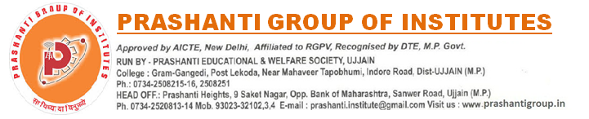

NOTICE CAMPUS DRIVE Date:24 Nov 2021
ThoughtWin IT Solutions Pvt. Ltd
BTECH (CS) (2021 Batch Pass-out)

Hirings of Freshers for below mentioned technologies:
1. Blockchain
2. ROR
3. ReactNative
4. ReactJS
5. IOS

Date : Wednesday, 1st Dec'21
Location : Indore
Package : Salary no bar but as per skills and knowledge of the technology.
Skills:
▪ Quick thinking and problem solving skills
▪ Excellent techincal skills
▪ Able to work independently and as a team player
▪ Excellent verbal communication skills
▪ Basic Knowledge of OOPS, Data Structure

Director
Training, Placement & Development
Prashanti Group of Institutes, Ujjain

