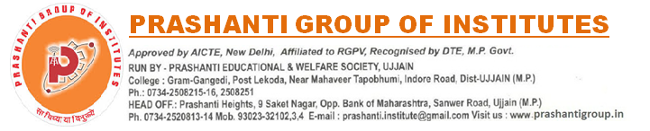

NOTICE CAMPUS DRIVE Date:24 Nov 2021
INDIA MART Pvt Ltd.

MBA, BBA, Bcom, Bsc,. ( 2020 & 2021 Batch Pass-out)

- Executive NSD Client Acquisition
- Executive Client Servicing
- Executive Client Division

Package: They will be paid a salary of Rs 3.4 LPA CTC to 4 LPA CTC (all inclusive )

Candidates will be on rolls of the company and apart from the industry based remuneration.
Position holder will be an individual contributor, responsible to drive sales activities within assigned region.
Skills:
▪ Quick thinking and problem solving skills
▪ Able to work independently and as a team player
▪ Excellent verbal communication skills
▪ Excellent active listening skills

Director
Training, Placement & Development
Prashanti Group of Institutes, Ujjain

